Project Design Phase-II
Data Flow Diagram & User Stories

Date | 08 October 2026
Team ID | 9100RootAccess
Project Name | Auto Ticket Classification using ServiceNow Flow Designer
Maximum Marks | 4 Marks

Data Flow Diagrams:
A Data Flow Diagram (DFD) is a traditional visual representation of the information flows within a system. A neat and clear DFD can depict the right amount of the system requirement graphically. It shows how data enters and leaves the system, what changes the information, and where data is stored.
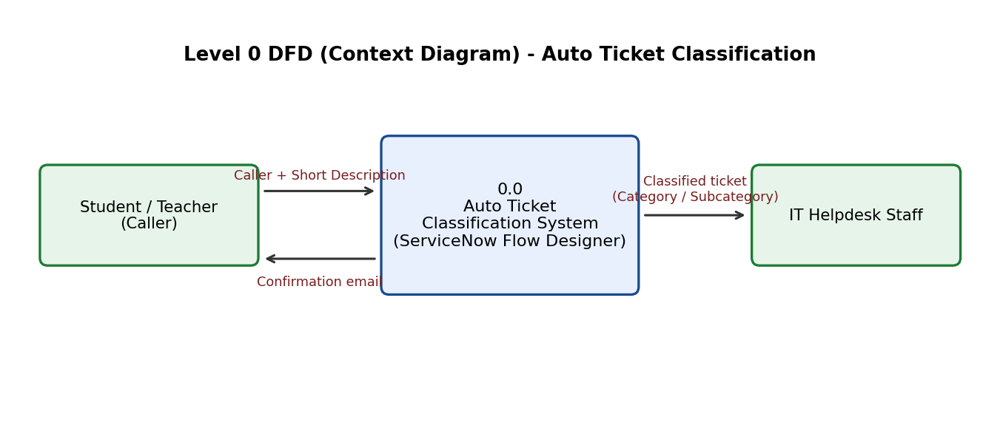
Level 1: Automatic classification and notification flow
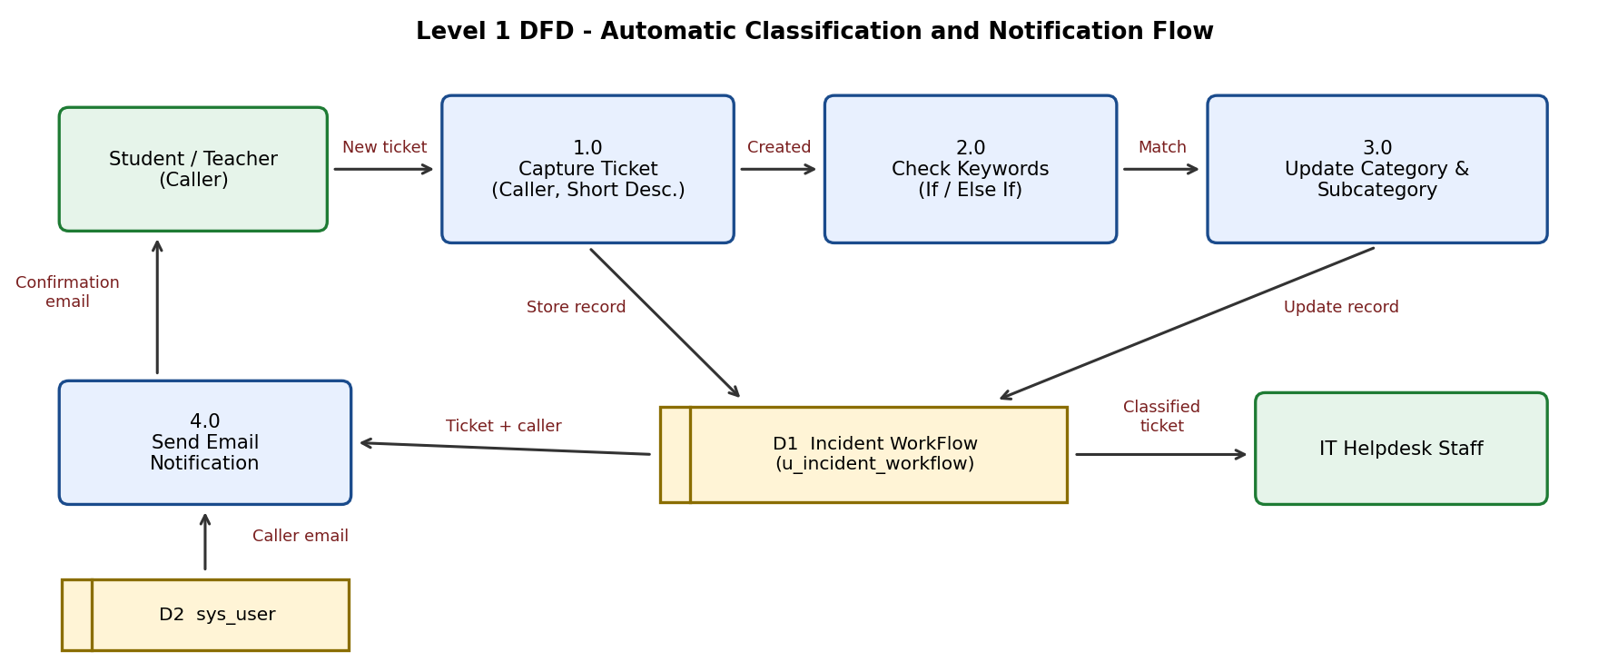

User Stories
Use the below template to list all the user stories for the product.
User Type | Functional Requirement (Epic) | User Story Number | User Story / Task | Acceptance criteria | Priority | Release
Student / Teacher (Caller) | Ticket Submission | USN-1 | As a caller, I can open a new Incident WorkFlow record and select my name as Caller so the ticket is linked to me. | Caller field resolves to my user record | High | Sprint-1
 |  | USN-2 | As a caller, I can describe my problem in the Short Description so the helpdesk knows the issue. | Record cannot be submitted without Short Description; ticket number INCxxxxx is generated | High | Sprint-1
 | Automatic Classification | USN-3 | As a caller, I do not have to pick Category or Subcategory because they are filled automatically after I submit. | After reload, e.g. Network / Wi-Fi or Hardware / Projector is shown | High | Sprint-2
 | Email Notification | USN-4 | As a caller, I receive an email confirming my request was submitted. | Email 'Your Request for the issue has been submitted.' appears in System Logs > Emails for my address | High | Sprint-2
IT Helpdesk Staff | Ticket Handling | USN-5 | As IT staff, I see Category and Subcategory already filled so I do not review each ticket manually. | Category and Subcategory are populated on every newly created ticket matching a keyword | High | Sprint-2
 |  | USN-6 | As IT staff, I see only the subcategories that belong to the chosen Category if I need to correct a ticket. | Network shows Wi-Fi; Hardware shows Projector; Access shows Forgot Password; Performance shows Slow Computer | Medium | Sprint-1
 |  | USN-7 | As IT staff, I can set State, Assigned group and Assigned to on a ticket. | State offers New, In progress, On hold, Resolved, Closed; group and user fields use reference lookups | Medium | Sprint-1
Administrator | Flow Configuration | USN-8 | As an administrator, I can add or change keyword conditions in Flow Designer without writing scripts. | New Else If branch with Update Record works after the flow is activated | Medium | Sprint-2
 | Deployment | USN-9 | As an administrator, I can complete the Project Update Set and export it to XML to move it to another instance. | Update set state is Complete and an XML file is downloaded | High | Sprint-3
 | Testing and Validation | USN-10 | As an administrator, I can test the flow with sample tickets and check the email log to confirm it works end to end. | Wi-Fi and Projector test tickets are classified correctly and emails are logged | Medium | Sprint-3

Team Task Allocation
Each team member was assigned four activities from the project milestones (durations as shown in the workspace).
Milestone | Activity | Assigned To | Duration
Milestone 1: Requirement Analysis & Planning | Activity 1: Business Use Case | Dakshayani R N R (Team Lead) | 5m
Milestone 1: Requirement Analysis & Planning | Activity 2: Creation of New Update Set | Harini Sri S | 5m
Milestone 1: Requirement Analysis & Planning | Activity 3: Navigation Steps in Picture View | Rubiga I | 5m
Milestone 2: Backend Development & Configuration | Activity 1: Creation of Custom Table to Store Tickets | Harini Sri S | 5h 50m
Milestone 2: Backend Development & Configuration | Activity 2: Field Creation and Data Type Configuration | Dakshayani R N R (Team Lead) | 1h 10m
Milestone 2: Backend Development & Configuration | Activity 3: Implementing Dependency Between Fields | Rubiga I | 0m
Milestone 3: Automation using Flow Designer & Email Notification | Activity 1: Auto Classification using Flow Design | Rubiga I | 5h 0m
Milestone 4: Testing, Validation & Security | Activity 1: Test Scenario 1 | Dakshayani R N R (Team Lead) | 5m
Milestone 4: Testing, Validation & Security | Activity 2: Test Scenario 2 | Rubiga I | 5m
Milestone 4: Testing, Validation & Security | Activity 3: Test Scenario 3 | Harini Sri S | 5m
Milestone 5: Deployment & Conclusion | Activity 1: Make Update Set to Complete State | Dakshayani R N R (Team Lead) | 5m
Milestone 5: Deployment & Conclusion | Conclusion | Harini Sri S | 5m

